**TORSDAG**

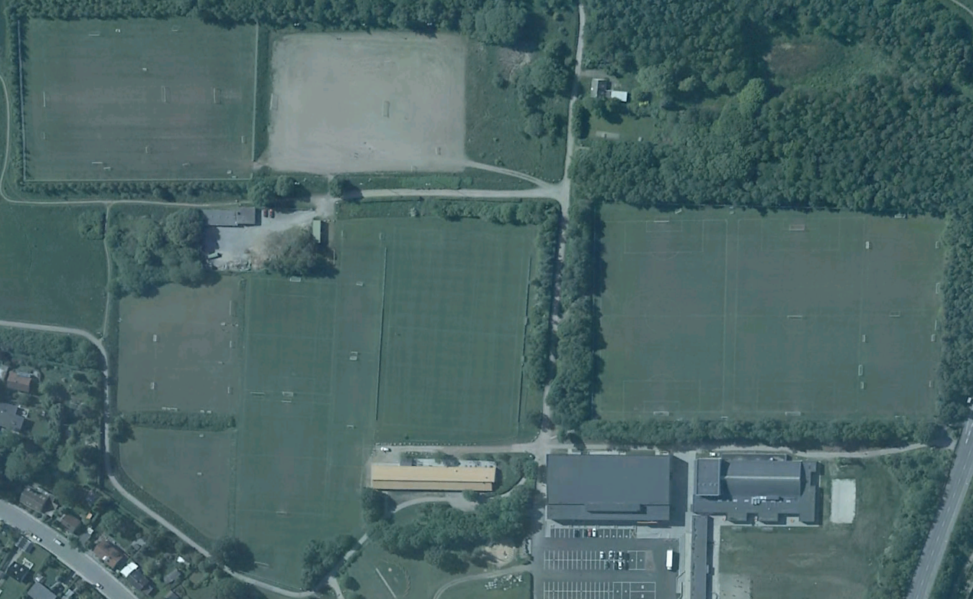

**Bane 7-8**

**16.30-18.00:**

**18.30-20.00:**

**Bane 5a-b 6a-b**

(5-mands)

**15.00-16.00:**

FC Prostata

**16.30-18.00:**

U10 Drenge (11)

**18.30-20.00:**

Herre 4

**20.00-21.30:**

Herre 6 (Lasse)

**Målmandstr.**

**Bane 9-10-11-12**

(3-mands)

**16.30-18.00:**

U9 Drenge (12)

**18.30-20.00:**

U19 Drenge 5 (03-02)

**Bane 2a-b**

(8-mands)

**16.30-18.00:**

U14 Drenge 1-2 (07)

**18.30-20.00:**

Herre 3

U19 Drenge 1 (03-02)

**Lille Kunstgræsbane**

**16.30-18.00:**

U11 Drenge (10)

**18.30-20.00:**

Herre 5 (Højbo)

**Bane 1**

**16.30-18.00:**

Disney Piger

**Målmandstr.**

**Bane 4**

**16.30-18.00:**

U12 Drenge (09)

U18 Piger AGF

**18.30-20.00:**

Damer 1-2-3

**Bane 3**

**16.30-18.00:**

U13 Drenge 1-2-3 (08)

**18.30-20.00:**

Herre 1-2

**Kunstgræsbane**

**16.30-18.00:**

U19 Drenge 2-3-4-6 (03-02)

**18.30-20.00:**

U17 Drenge 1-2 (04)

**Klubhuset**

**Lyseng Idrætscenter**