**TIRSDAG**

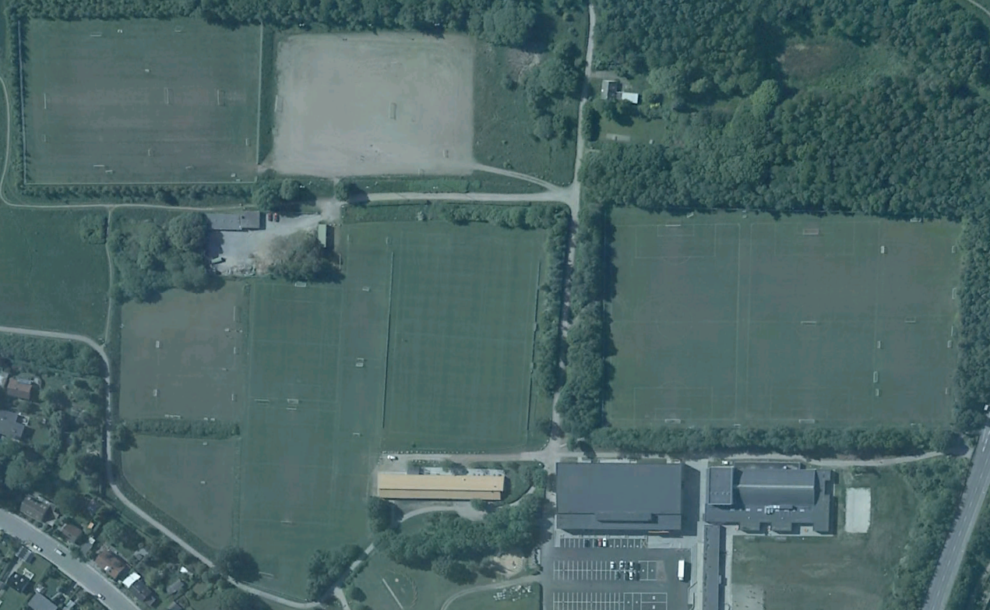

**Bane 4**

**16.30-18.00:**

U10 Drenge (11)

Future-piger AGF

**18.30-20.00:**

Damer 1

U18 Piger AGF

**Bane 7-8**

**16.30-18.00:**

**18.30-20.00:**

**Lille Kunstgræsbane**

**16.30-18.00:**

**18.30-20.00:**

U19 Drenge 5 (03-02)

**Bane 5a-b 6a-b**

(5-mands)

**16.30-18.00:**

Disney Piger

**18.30-20.00:**

Herre 4

**Målmandstr.**

**Bane 9-10-11-12**

(3-mands)

**16.30-18.00:**

U09 Drenge (12)

**18.30-20.00:**

Herre 6 (Lasse)

**Bane 2a-b**

(8-mands)

**16.30-18.00:**

U13 Drenge 1-2-3 (08)

**18.30-20.00:**

Herre 3

U19 Drenge 1 (03-02)

**Bane 1**

**16.30-18.00:**

U7 Drenge (14)

U8 Drenge (13)

**Målmandstr.**

**Bane 3**

**16.30-18.00:**

U19 Drenge 2-3-4-6

(03-02)

**18.30-20.00:**

Herre 1-2

**Kunstgræsbane**

**16.30-18.00:**

U11 Drenge (10)

U12 Drenge (09)

**18.30-20.00:**

U17 Drenge 1-2 (04)

**Klubhuset**

**Lyseng Idrætscenter**