**ONSDAG**

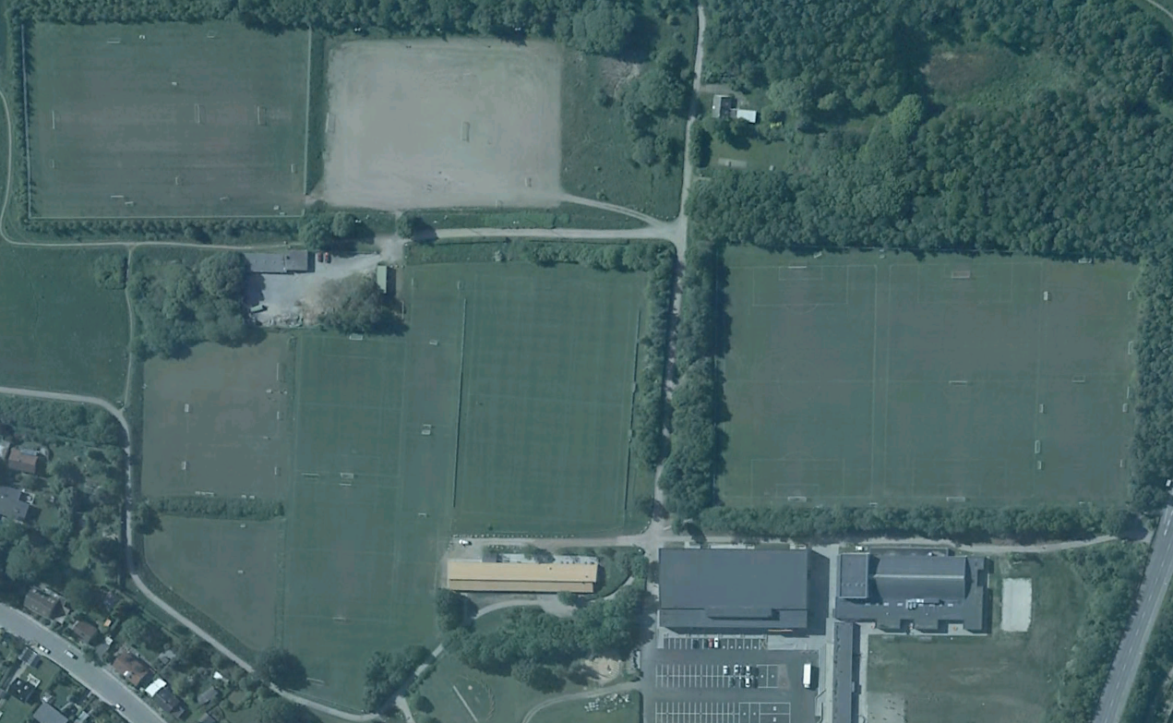

**Bane 7-8**

**16.30-18.00:**

**18.30-20.00:**

U14 Piger 2 (07)

**Lille Kunstgræsbane**

**16.30-18.00:**

U15 Drenge 3 (06)

**18.30-20.00:**

U18 Piger 2 (04-03)

**Bane 5a-b 6a-b**

(5-mands)

**16.30-18.00:**

U9 Piger (12)

**18.30-20.00:**

Herre 7 (Rasmus)

**Målmandstr.**

**Bane 9-10-11-12**

(3-mands)

**16.30-18.00:**

U6 Drenge (15)

**18.30-20.00:**

Fodbold Fitness

**Bane 2a-b**

(8-mands)

**16.30-18.00:**

U12 Piger (09)

U13 Piger (08)

**18.30-20.00:**

U16 Piger 1 (05)

U15-16 Piger 2 (06-05)

**Bane 1**

**16.30-18.00:**

U6 Piger (15)

U7 Piger (14)

U8 Piger (13)

**Målmandstr.**

**Bane 4**

**16.30-18.00:**

U14 Drenge 1-2-3 (07)

**18.30-20.00:**

U16 Drenge 1-2-3 (05)

**Bane 3**

**16.30-18.00:**

U10 Piger (11)

U11 Piger (10)

**18.30-20.00:**

U14 Piger 1 (07)

U15 Piger 1 (06)

**Kunstgræsbane**

**16.30-18.00:**

U15 Drenge 1-2 (06)

**18.30-20.00:**

Oldboys kamp

**Klubhuset**

**Lyseng Idrætscenter**